class ItemToPurchase:

def __init__(self):

# Initialize item attr

self.item_name = "none" #string

self.item_price = 0.0 #float

self.item_quantity = 0 #integer

def print_item_cost(self):

# Print cost of item

total_cost = self.item_price * self.item_quantity

print(f"{self.item_name} {self.item_quantity} @ ${self.item_price} = ${total_cost}")

def main():

# Get Item 1 info

print("Item 1")

item1 = ItemToPurchase()

item1.item_name = input("Enter the item name: ")

item1.item_price = float(input("Enter the item price: "))

item1.item_quantity = int(input("Enter the item quantity: "))

# Get Item 2 info

print("\nItem 2")

item2 = ItemToPurchase()

item2.item_name = input("Enter the item name: ")

item2.item_price = float(input("Enter the item price: "))

item2.item_quantity = int(input("Enter the item quantity: "))

# Display cost for each item and the total cost

print("\nTOTAL COST")

item1.print_item_cost()

item2.print_item_cost()

# Calculate and print the total cost

total_cost = (item1.item_price * item1.item_quantity) + (item2.item_price * item2.item_quantity)

print(f"\nTotal: ${total_cost}")

# Run main function

main()

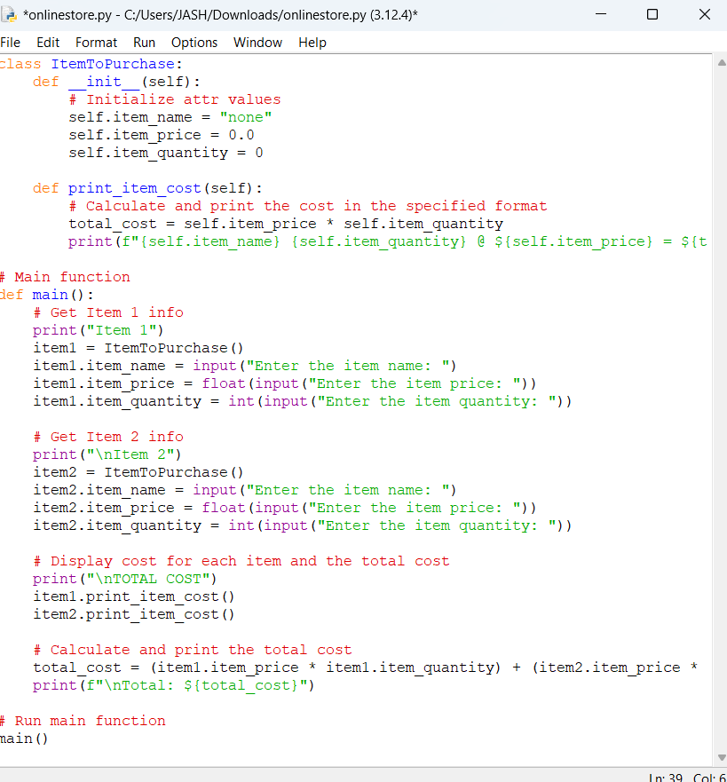

Execute Code:

